8 week Yoga Class
Middleborough Town Hall
Second floor, Grand hall

Tuesday, February 24th – Tuesday, April 28th
(Skipping Tuesday April 21st)
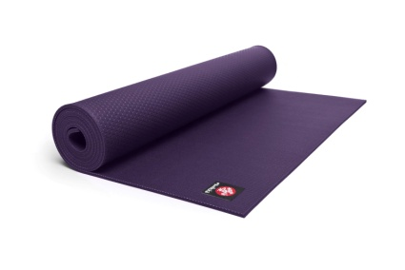
Time: 5:00pm – 6:00pm
Please bring mat to class

To register online
http://gicmiddleborough.weebly.com/wellness-activities.html

